**Neural Networks Report**

CSE 474 Group 41 Liam Carroll & Jeremy Baumann

* Explanation with supporting figures of how to choose the hyper-parameter for the neural network: 20 points
* Accuracy of classification method on the handwritten digits test data: 10 points
* Accuracy of classification method on the AI Quick Draw data set: 10 points
* Compare the accuracy and training time of deep neural network (using TensorFlow) with different number of layers : 10 points

**Choosing the hyper-parameter**

In order for us to choose a hyper-parameter, we had to do an analysis of such. We iteratively calculated the accuracy over a range of the hyper-parameters, and then graphed them to see the linear relationship.

We used the MNIST sample dataset for analysis.

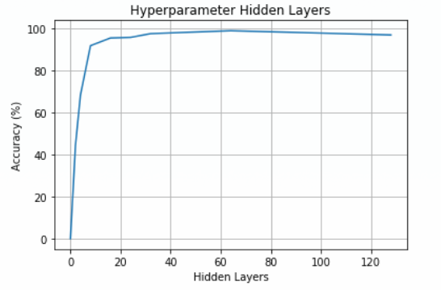

As you can see for the hidden layers, the relationship between accuracy and amount of units takes a logarithmic form. The best case was at 64 units, at 99% accuracy.

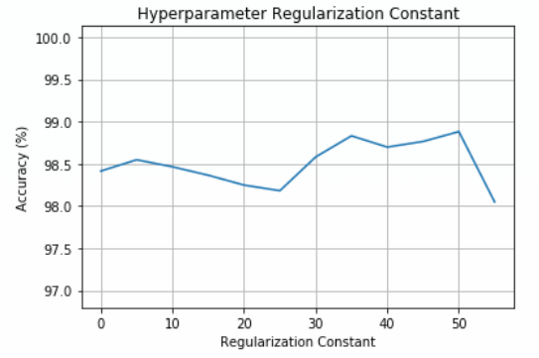

The regularization constant however did not take a linear form, rather frequented between 98.2% and 98.8%. The best case was 50 for the regularization constant at 98.8%.

**Accuracy of classification (Handwritten Digits)**

Our best accuracy for the Handwritten Dataset was 98.99933% with a regularization constant of 35 and 64 hidden units.

**Accuracy of classification (AI Quick Draw)**

Our accuracy with regularization constant of 35 and 64 hidden units was 73.761%

**Accuracy of deep neural network**

The deep neural network (using TensorFlow), when run with two hidden layers, had an accuracy of 61.416%. When run with three hidden layers, it had an accuracy of 62.482%. When run with five hidden layers, it had an accuracy of 61.736%. Finally, when run with seven hidden layers, it had an accuracy of 60.352%. The accuracy changed very little as the number of hidden layers increased.

**Hidden layers: 2**



**Hidden layers: 3**



**Hidden layers: 5**



**Hidden layers: 7**

